**What is Amazon EC2 Auto Scaling**

* Amazon EC2 autoscaling is designed as a fully managed service that controls the number of running instances, in case your workload is higher, it will match by launching more instances instantaneously.
* Unlike load balancer, you don’t provision EC2 Instances in advance and register as a target but you define the whole configuration in the Launch template which will scale out or scale in based on the traffic.
* In auto-scaling, you also define what will be minimum capacity, desired capacity, and maximum capacity. Autoscaling makes sure that the number of instances specified in desired capacity is always running when traffic is normal, it will scale in when traffic is lowest and scale-out when running there is a spike.
* While creating auto-scaling, it requires a Launch template where you specify which AMI to choose, what will be instance type, security group associated, and all other options required to launch an EC2 Instance including key pair.

# ****Lab Steps****

## ****Task 1: Sign in to AWS Management Console****

1. Click on the **Open Console** button, and you will get redirected to AWS Console in a new browser tab.
2. On the AWS sign-in page,

* Leave the Account ID as default. Never edit/remove the 12-digit Account ID present in the AWS Console. Otherwise, you cannot proceed with the lab.
* Now copy your **Username** and **Password** in the Lab Console to the **IAM Username and Password** in AWS Console and click on the **Sign-in** button.

1. Once Signed In to the AWS Management Console, make the default AWS Region as **US East (N. Virginia) us-east-1.**

**Task 2: Creating Launch Template**

In this task, we are going  to create Launch Templates, which are a recommended approach for creating instances in Auto Scaling groups. By creating a Launch Template, we define the configuration settings for their EC2 instances, including the Amazon Machine Image (AMI), instance type, network settings, and security groups.

1. Make sure you are in the **US East (N. Virginia) us-east-1** Region before proceeding with the Lab.
2. Navigate to **EC2** by clicking on the **Services** menu in the top, then click on **EC2** in the **Compute** section.
3. In the left navigation menu, scroll down to **Launch Templates**and click on **Create launch template** button.



1. Launch template name: Enter **whizlabsLT**
2. Template version description: Enter **Launch template version 1**
3. Launch template contents:
   * Amazon machine image (AMI): Select **Amazon Linux 2 AMI**
   * Instance type: Select **t2.micro**



* Key pair (login):
  + Key pair name: **Don't include in launch template**

1. Network settings:
   * Security groups: Select the **Default security group of Default VPC**
2. Keep all the settings as default.
3. Now, click on **Create launch template**button
4. Launch template is now created.
5. Click on the **View launch template** button.
6. Launch template is now listed.

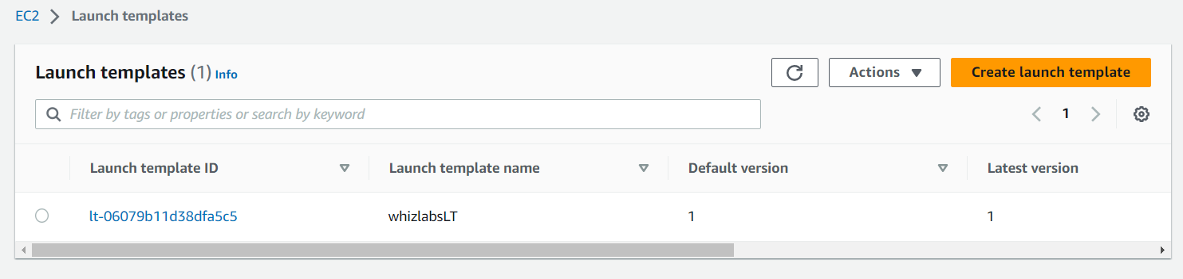

**Task 3: Create an Auto Scaling Group**

In this task, we are going to create an Auto Scaling group, which is a collection of EC2 instances that can automatically scale based on predefined policies and conditions.

1. An Auto Scaling group is a scalable collection of EC2 instances. When you create an Auto Scaling group, you include information such as the subnets for the instances and the number of instances the group must maintain at all times.
2. Go to the left menu under **EC2** and choose **Auto Scaling Group** under **Auto Scaling**
3. Click on the **Create Auto Scaling group** button.

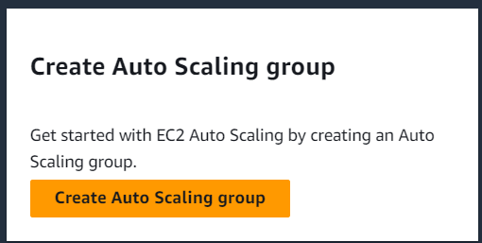

1. **Step 1: Choose launch template or configuration**
   * Auto Scaling group name: Enter **whiz-ASG**
   * Launch template: Select **whizlabsLT**
   * Click on the **Next** button.
2. **Step 2: Configure settings**
   * VPC: Select the **Default VPC** from the list.
   * Subnet: Select all the subnets.
   * Click on the **Next**button.

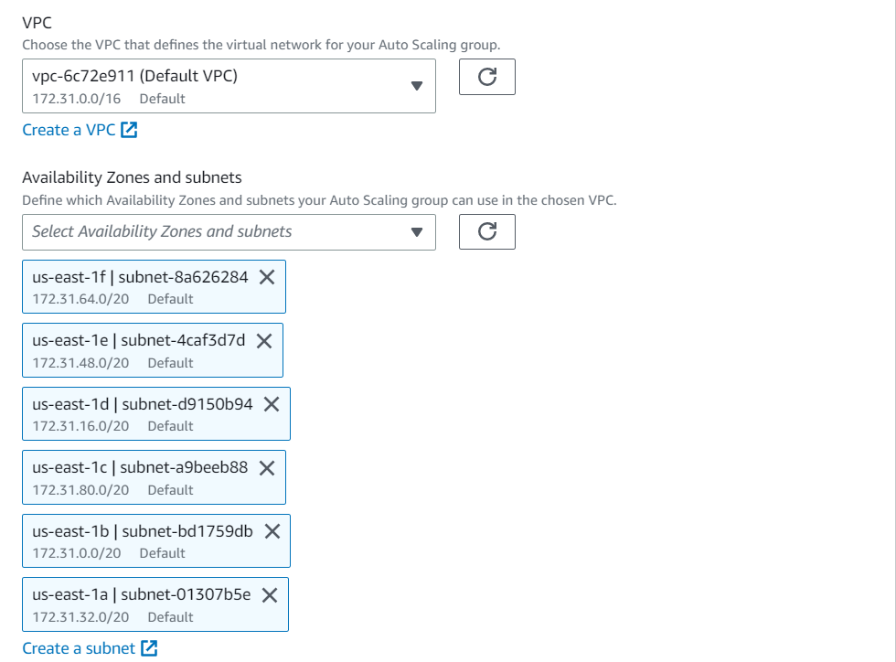

1. **Step 3: Configure advanced options**
   * No changes are needed on this page, click on the **Next**button.
2. **Step 4: Configure group size and scaling policies**
   * Under Group size – optional
     + Desired capacity: Enter **2**
     + Minimum capacity: Enter **2**
     + Maximum capacity: Enter **2**

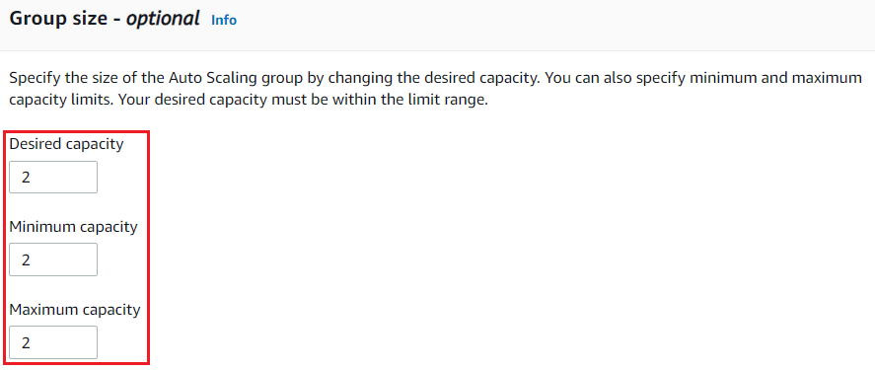

* Under Scaling policies – optional
  + Select **None**

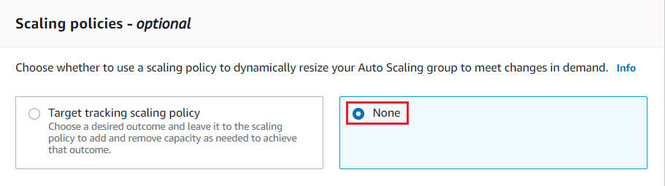

* Under Instance scale-in protection
  + No changes are needed, click on the **Next**button

1. **Step 5: Add notifications**
   * No changes are needed on this page, click on the **Next**button.
2. **Step 6: Add tags**
   * Enter tags in key-value pairs to identify your auto-scaling group.
   * Click on the **Add tag** button.
   * Key: **Name**
   * Value: **ASG-EC2**

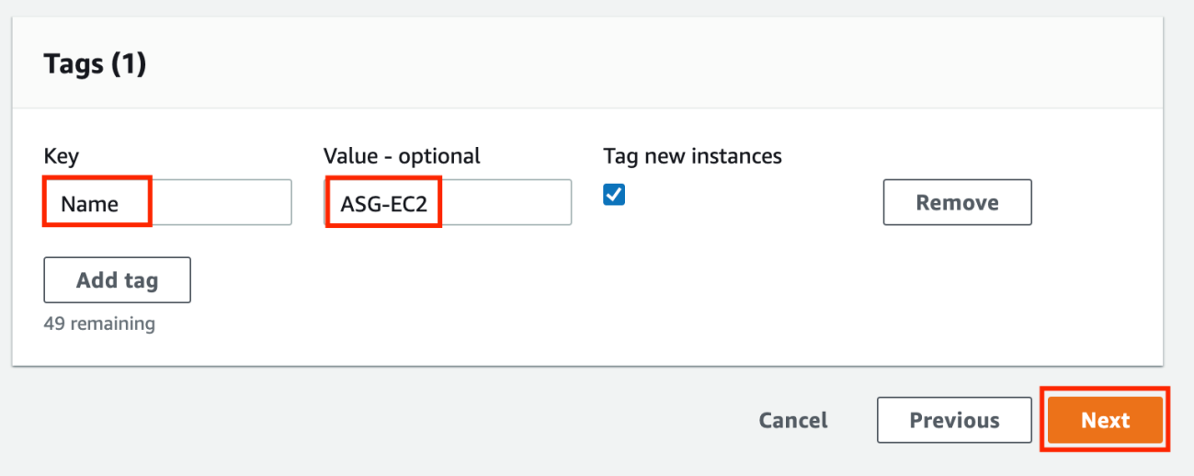

* + Click on the **Next**button

1. Now scroll down and click on the **Create Auto Scaling group** button.
2. Whiz-ASG Auto scaling is created successfully.
3. You will be redirected to the autoscaling group page, you will be able to see that two instances are launched by the autoscaling group.
4. Now go to the EC2 instances list. You will see that there are **two new running instances** (which were created by your autoscaling group) You can confirm this from their tag name, which you gave at the time of creating the autoscaling group.
5. You have successfully created an autoscaling group with a policy of a minimum of 2 and a maximum of 2 instances.

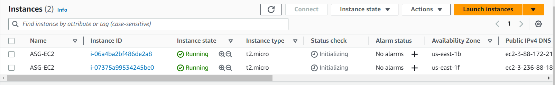

**Task 4: Test Auto Scaling Group**

In this task, we are going to validate the functionality of the Auto Scaling group

1. For testing the auto-scaling policy, go to the EC2 instance list and select one of your instances.
2. Next, select an instance and click on **Instance state**and then **Stop instance.**
3. Click the **Stop** button on the pop-up window to stop your instance.
4. Once your instance is stopped (after 1-2 minutes) you can see that your stopped instance will be terminating automatically, and a new instance will be launched to fulfill the policy condition. A sample screenshot is provided below:

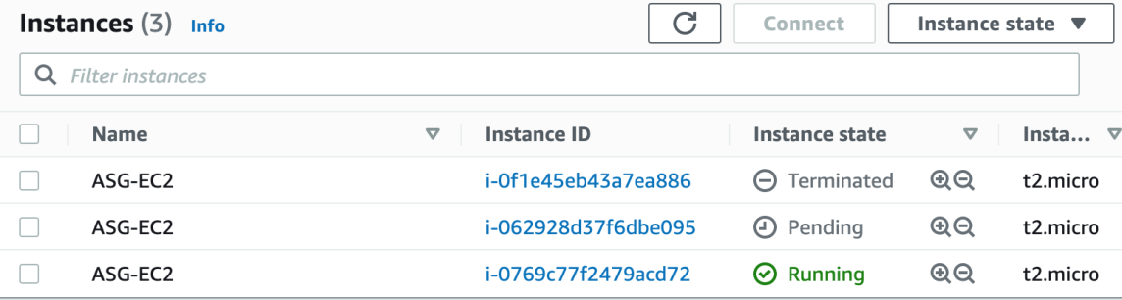

* **Note:**Launching a new instance may take a few minutes, you can refresh the page to view the new instance.